2012 Newsletter – October Edition

E-mail: cupe.local21@sasktel.net Fax: (306) 352-5848 Phone: (306) 352-8282

Membership Meeting: 2nd Tuesday of each Month (7:00 pm – Italian Club – 2148 Connaught St.)
Table Officers  Tim Anderson  President  Temp. Vacant  Vice President  Wade Zalopski  Recording Secretary  Communications  Darren Fox  Secretary Treasurer  Cindy Jessop  2nd Vice President  Grievance Chair  Community &  Corporate Services  (352-8282 )  Clint Driedger  2nd Vice President  Grievance Chair  Public Works  (581-2954 )  Executive  Alvin Huber  Chris Szakacs  Carmel Mitchell  Alberta Heisler  Brendon Moat  Reg Wilke  Saul Lipton  Dave Gooding  Sergeant-at-Arms  Wayne Toker  Trustees  Ken Kabatoff  Steve Frankiewitz  Allen Kreshewski  CUPE National Representative  Guy Marsden |   Your Local 21 communications committee extended invitations to all candidates running for civic office to take part in a one-on-one video interview. The candidates were provided with a list of 14 important questions to respond to.  To view the candidates video interview please visit: www.wantsvsneeds.ca.  Once on our webpage, select the “Candidate Interviews” tab at the top of the page. If you find that your candidate is not posted, please know that some accepted our invitation; others declined or did not respond.  I’d like to take this opportunity to thank Barry Rudd of Firecube Video and Jack Hilkewich for their professionalism and hard work thru out this campaign, and for putting up with me. Thank you Sister Janet Szliske CUPE Communications Representative for your thoughts and recommendations.


FRONTLINE WORKER

21 News / Views
Union Work – Union Proud
The Headlines Local / Provincial / Federal / World

Rick Hansen Optimist Playground restored with help from Regina city workers (CUPE press release) Sept. 4, 2012 01:55 PM

REGINA – When the Rick Hansen Optimist Playground was damaged by vandalism last year, only one fully wheelchair accessible playground remained available in Regina. CUPE 21, City of Regina outside workers, and the Saskatchewan Building Trades Council stepped up to help fund the repairs. Donating $55,000 and providing the labour to replace equipment, the park was restored and re-opened just in time for summer.

The City of Regina thanked CUPE 21 and the Building Trades Council last week and will be locating a plaque recognizing their contribution on site later this year. “Regina’s parks are so important to residents and add to the quality of life residents enjoy here,” says CUPE 21 Recording Secretary/Communications executive member Wade Zalopski. “And because the Rick Hansen Optimist Park was fully-accessible, the restoration was even more important.”

Parents and children were upset at the playground closure after vandals lit a fire in A.E. Wilson Park on August 13, 2011. Rick Hansen Optimist playground is located in Regina’s northwest end at 1010 McCarthy Boulevard. CUPE 21 represents 1,250 outside municipal workers in Regina who keep roads safe, provide recreational services, upkeep and maintain arenas and rinks, collect garbage, take care of sewer and wastewater treatment, build and repair sidewalks, and maintain fire hydrants.

The crew that put the structure together …

District 1: Jennifer Mapplebeck, Peter Koch, Mackenzie Srochenski-Fyfe.
District 2: Shawn Coghill, Karlee Wiser, Jalyn Euteneier, Blake Bochinski, Bethany Jefferson.
District 3: Travis Tremblay, Jamiy-Lee Moran, Will Hopfauf, Rheanelle McKinnon.
District 4: Ron Perelitz, Thomas Ostopowich, Tanner Sobalofsky, John Richardson. …Thank You

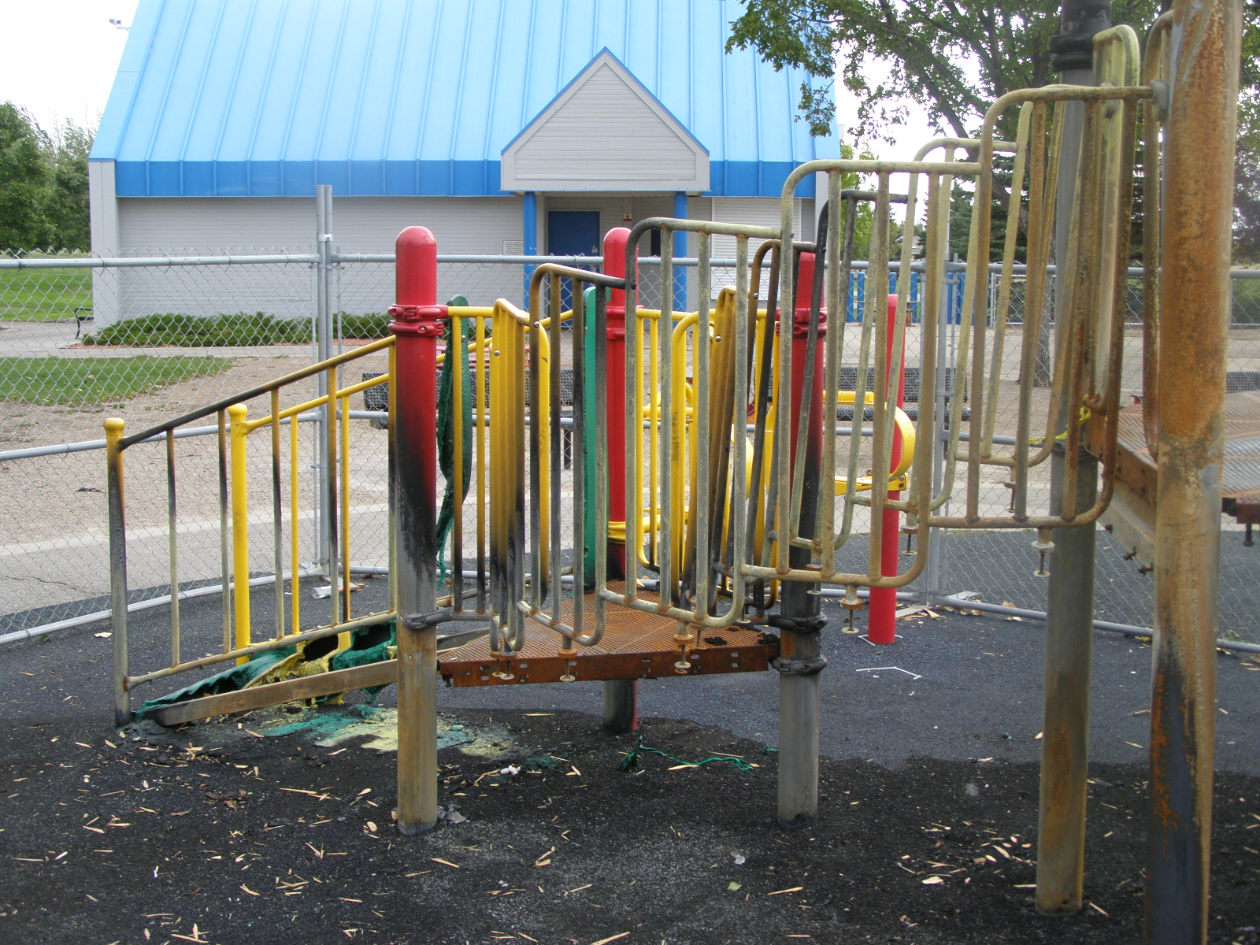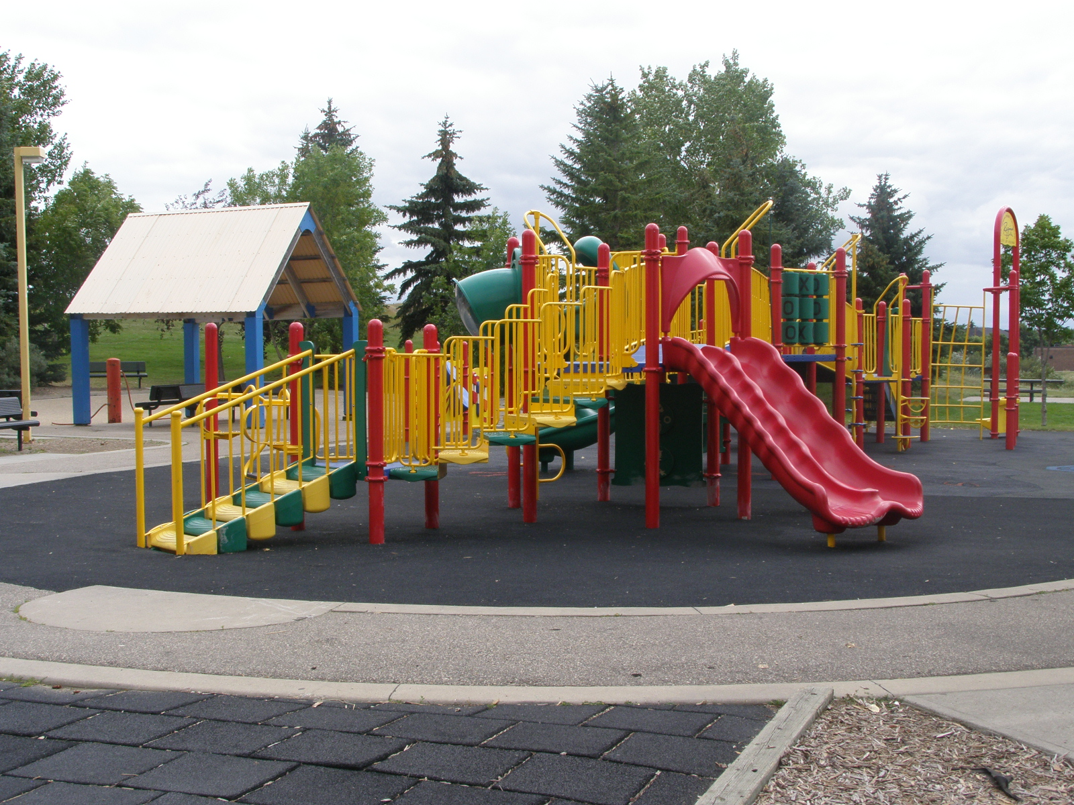
Regina Civic Election 2012
Please note: Starting with the 2012 election, a term for Mayor & Councilors will become 4 years.
Candidates for Mayor:
 BRASS, Liz
 BROWN, John
 DONNELLY, Marian
 ELLIOTT, Jim
 FOUGERE, Michael
 NOVAK, Chad
 OKOCHI, Meka
 SIEKAWITCH, Tim
 WEIBE, Charles
Candidates for City Council:

WARD 1 - Regina South-Centre
 Armstrong, Rob  Hewitt, Conrad  Klein, John  Kuster, Shawn  Madole, Terry
 Rey, Keith  Young, Barbara

WARD 2 - Regina South West
 Dittrick, Richard  Hawkins, Bob  Khan, Sam  McIntyree, Heather

WARD 3 - Regina Centre & West
 Anderson, Eric  Birley, Susan  Dixon, Shirley  Fraser, Shawn  Muir, Janice
 Slobodan, D. Justin  Young, Don

WARD 4 - Regina South East
 Beaudry-Mellor, Tina  Burnett, Bryon  Leitner, Perry  Smith, Darryl

WARD 5 - Regina East
 Findura, John (incumbent)  Ray, Bill  Ogunrinde, Femi

Ward 6 - Regina Centre & Northeast
 Etter, Sarah  Kirk, Allan  McDavid, Stephen  Murray, Wade (incumbent)

Ward 7 - Regina North
 Bryce, Sharron (incumbent)  Berehula, Danny  Stadnyk, Austin  Stewart, Colin

Ward 8 - Regina West
 O'Donnell, Mike (incumbent)  Runge, Brian
Ward 9 - Regina Northwest
 Hincks, Terry (incumbent)  Knight, Harold  Mooney, Kevin  Thomas, Dawn

Ward 10 - Regina Far North
 Flegel, Jerry  Szarka, Chris (incumbent)

_______________________________________________________________________________________________________________
A Blast from the Past
Fiacco and crew give Mosaic 5 year free ride – Saskatchewan Federation of Labour SFL

- So, does a huge global multi-national corporation really need Regina taxpayers and individual home-owners to pick up the property tax tab for them? How can any politician say they are acting responsibly and in the interests of the citizens when they hand over $1.5 million dollars of taxpayers money to a corporation that never expected to receive the grant in the first place?

- Don't let anyone spin it to you in any other way, Mosaic had already decided to set up their corporate headquarters in a new downtown Regina office tower before the brain trust over at Regina City Council got generous and voted to give them an early Christmas present.

- According to an article in the December 15, 2010 Regina Leader-Post, the city, school boards, and libraries will all feel the pinch so that Mosaic corporate executives can enjoy their nice new offices.

- "Mosaic is to save about $326,000 in taxes annually for five years. The city's annual share works out to nearly $128,000 a year and $134,000 for schools and about $64,000 to the library."

- A check of Mosaic’s October 2010 investor fact sheet from their website will reveal that the company is doing quite nicely already. In fact, their net assets are stated to be $13.1 billion.

- The President and CEO of Mosaic is James T. Prokopanko. According to Forbes, his base salary for 2010 was $933,333.00 plus stock options of $2.4 million plus other compensation for a total of $6,255,588.00. Not bad, eh?

- So there you have it, this company can afford to pay their CEO more than $6 million a year, but Fiacco, Fougere, and the rest of them, think they need a tax-payer funded subsidy and a 5 year free-ride. Has your street been plowed yet?

p.s. Mosaic was formed in 2004 by IMC Global and Cargill. Cargill holds 64% of Mosaic shares.

_______________________________________________________________________________________________________________

Regina Civic Election - October 24, 2012
VOTE

